

PP2905 Portable Tire Changer and Bead Breaker Assembly Instructions

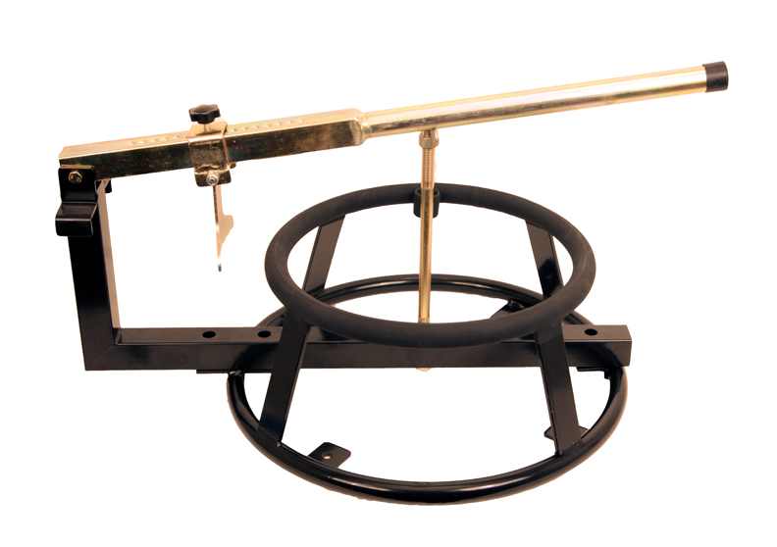

Thank you for purchasing the Pit Posse Portable Tire Changer and Bead Breaker! Enclosed are the instructions for assembly.

Any questions please call toll free: 866-447-6773

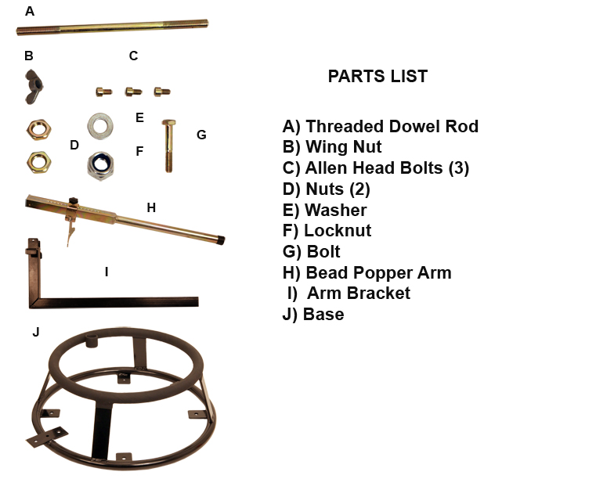

1) Align holes on arm bracket (I) with holes on base (J)
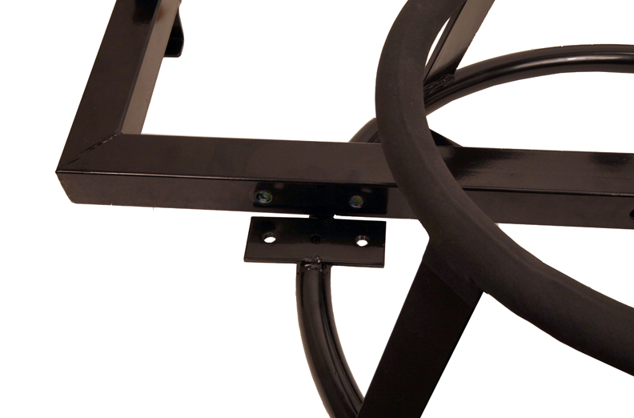
2) Attach arm bracket to base with three bolts (C)
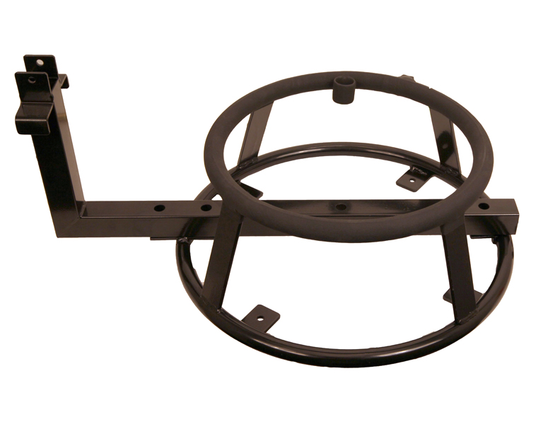
3) Attach threaded dowel rod (A) to arm bracket with nuts (D)
above and below bracket. Either side of rod can be used.

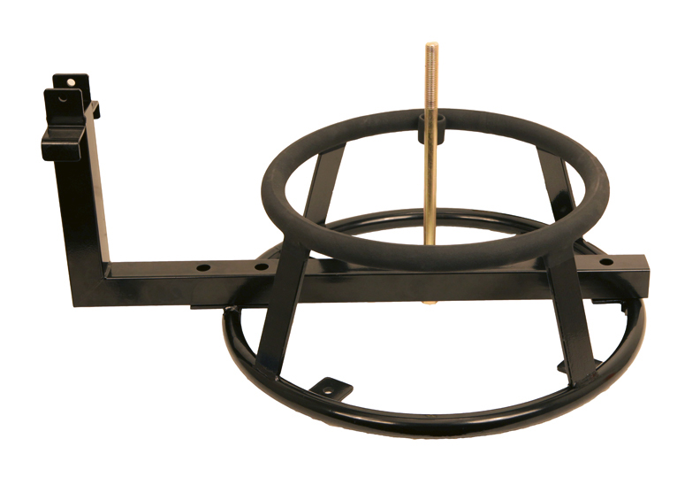

4) Attach bead popper arm (H) to arm bracket by running bolt
(G) through and securing with washer (E) and nut (F).

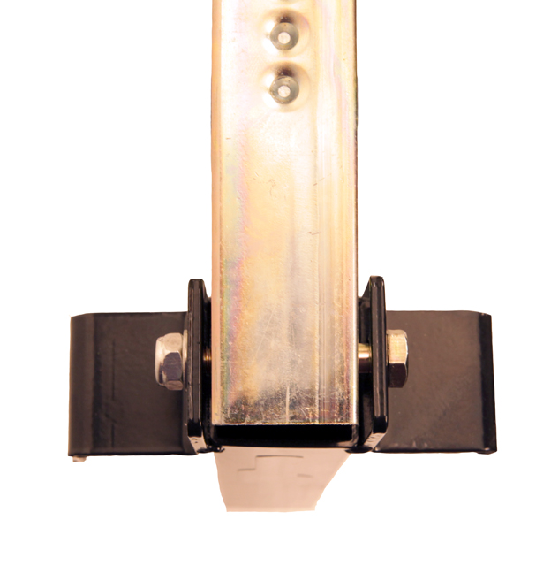
5) Attach wing nut (B) to threaded rod.

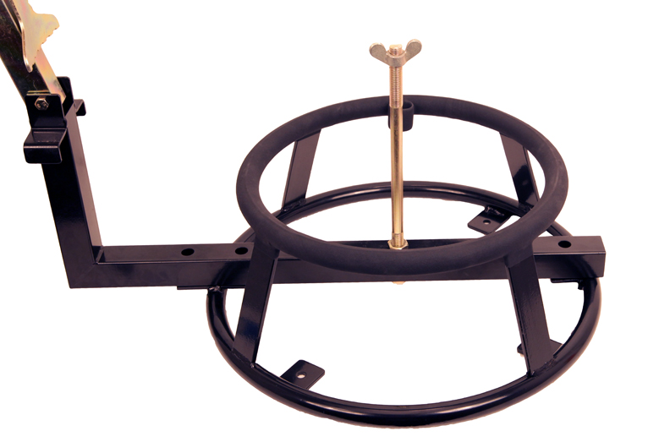

Completed assembly

